# SQL SERVER REPORTING SERVICES (SSRS)

Please see below:

## REPORT STRUCTURE FOR REPORTING SERVICES

Each Reporting Services paginated report contains two distinct sets of instructions a that determine what the report will contain. The first is the data definition. The data definition controls where the data for the report will come from and what information will be selected from that data. The second set of instructions is the report layout. The report layout controls how the information will be presented on the screen or on paper. Both of these sets of instructions are stored using the Report Definition Language (RDL).

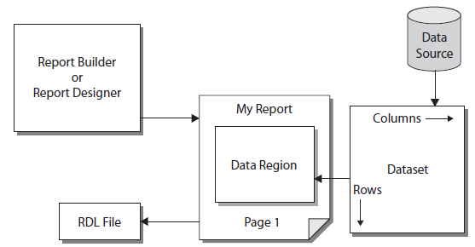

## REPORT DATA DEFINITION

The data definition for a paginated report contains two parts: the data source and the dataset. The data source is the database server or data file that provides the information for your report.

* The type of source you will be using for your data (for example, Microsoft SQL Server 2016, Oracle, DB2, or Microsoft Access). Reporting Services will use this information to determine how to communicate with the data source.
* The name of the database server or the path to the data file.
* The name of the database.
* The login for connecting to this data source, if a login is required.

When the report is executing, it uses the data source instructions contained in the report to gain access to the data source. It then extracts information from the data source into a new format that can be used by the report. This new format is called a dataset.

The content of the dataset is defined using a tool called the Query Designer. The Query Designer helps you build a database query.

The actual data is not stored in the definition of the dataset, but instead is selected from the data source when the report is run.

## REPORT LAYOUT

The data that the report has extracted into a dataset is not of much use to you unless you have some way of presenting it to the user. You need to specify which fields go in which locations on the screen or on paper.

You also need to add things such as titles, headings, and page numbers. All of this forms the paginated report layout.

In most cases, your report layout will include a special area that interacts with the dataset. This special area is known as a data region. A data region displays all the rows in the dataset by repeating a section of the report layout for each row.

## REPORT DEFINITION LANGUAGE (RDL)

The information in the data definition and the report layout is stored using the Report Definition Language (RDL).

This includes the data source instructions, the query information that defines the dataset, and the report layout. When you create a report in the Report Designer, it is saved in a file with an .rdl extension.

## RDS

Report data source

## RSD

Report data set

## TABLES, MATRICES, AND LISTS

In Reporting Services, tables, matrices, and lists are data regions that display paginated report data in cells that are organized into rows and columns. The cells typically contain text data such as text, dates, and numbers but they can also contain gauges, charts, or report items such as images. Collectively, tables, matrices, and lists are frequently referred to as tablix data regions.

Tables and matrices have a tabular layout and their data comes from a single dataset, built on a single data source.

The key difference between tables and matrices is that tables can include only row groups, whereas matrices have row groups and column groups.

Lists are a little different. They support a free-layout that and can include multiple peer tables or matrices, each using data from a different dataset. Lists can also be used for forms, such as invoices.

The following pictures show simple reports with a table, matrix, or list.

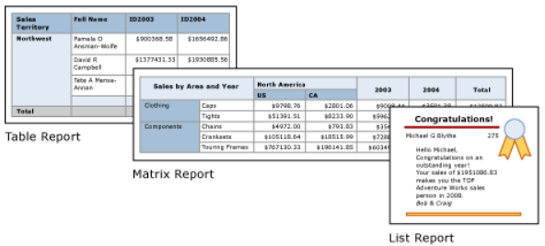

## TABLE

Use a table to display detail data or organize the data in row groups or both.

The Table template contains three columns with a table header row and a details row for data. The following figure shows the initial table template, selected on the design surface:

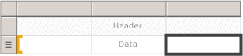

You can group data by a single field, by multiple fields, or by writing your own expression and display aggregated values for grouped data, or add totals to groups. For example, if your table has a row group called [Category], you can add a subtotal for each group as well as a grand total for the report.

We can initially hide detail or grouped data, and include drilldown toggles to enable a user to interactively choose how much data to show.

## MATRIX

Use a matrix to display aggregated data summaries grouped in rows and columns similar to a PivotTable or crosstab. The number of rows and columns for groups is determined by the number of unique values for each row and column groups. The following figure shows the initial matrix template selected on the design surface:

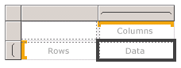

## LIST

Use a list to create a free-form layout. You are not limited to a grid layout, but can place fields freely inside the list.

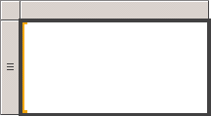

You can use a list to design a form for displaying many dataset fields or as a container to display multiple data regions side by side for grouped data.

For example, you can define a group for a list; add a table, chart, and image; and display values in table and graphic form for each group value, as you might for an employee or patient record.

## TYPE OF REPORTS

* Stepped report (Data has been grouped and no drill down functionality)
* Drill down report
* Drill through
* Sub report / Linked Reports
* Cascading report

## REPORT SERVER CONFIGURATION MANAGER

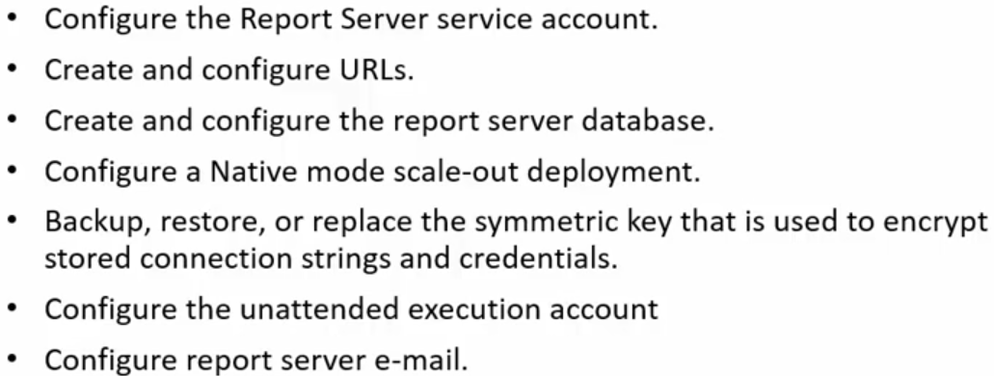

## REPORT SERVER (WEB SERVICE URL)

Report server is used to manage reports by admin users.

## REPORT BROWSER (WEB PORTAL URL)

Report browser is used to view deployed reports. End users, business users and admins have access to it.

## SUBSCRIPTION

A subscription is a report delivered via e-mail or to a shared folder. The end user can receive reports in different formats (Word, PDF, CSV, others) via a set schedule.

[Requirements for subscriptions](javascript:void(0)):

* Before we can deploy a report using the e-mail system, the report server must be configured for an SMTP server
* Before we can deploy the file share delivery system, you must have target folder already defined and permission set for sharing
* Before you can subscribe to a report, the report data source must be configured to use stored credentials

## 

# COMMON FORMATTING TECHNIQUES

Below are some commonly used formatting techniques:

## REPEATING HEADER & TITLE

Select the title / header and press F4 to access the properties:

FixedData = True

RepeatOnNewPage = True

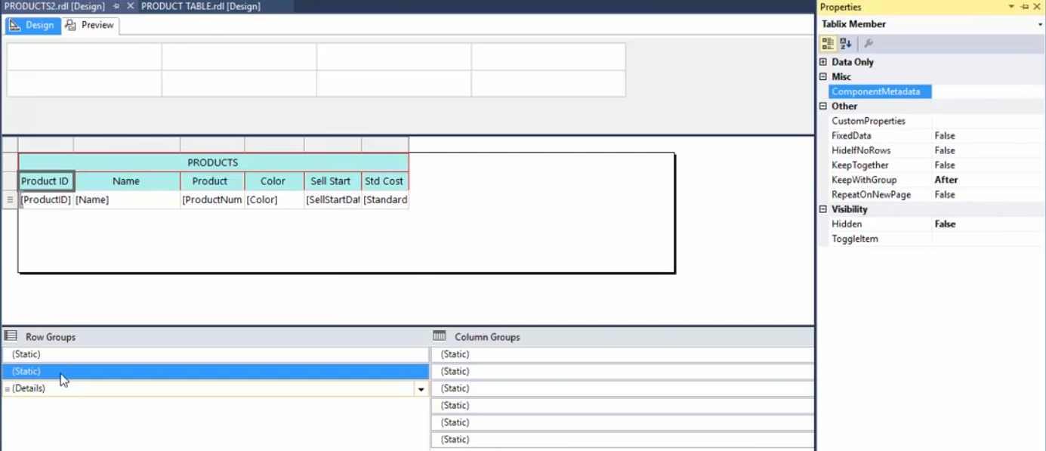

## INTERACTIVE FILTER

To enable interactive filter:

Right click on the column and press F4 or select from the menu as shown below:

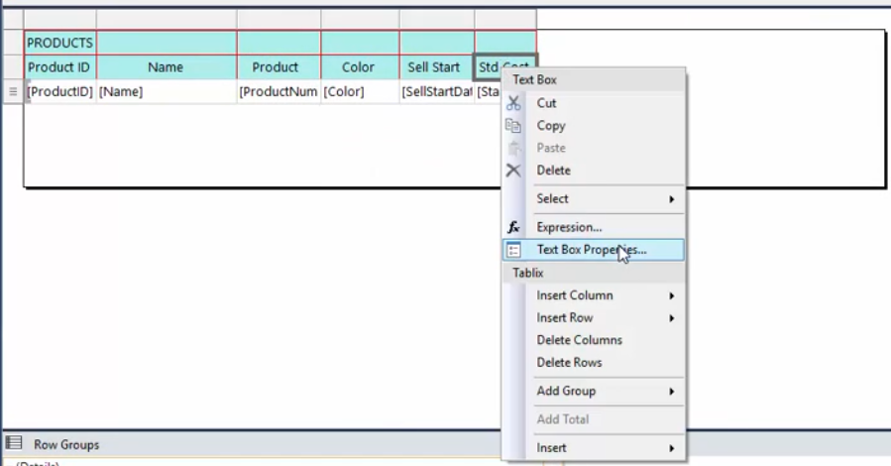

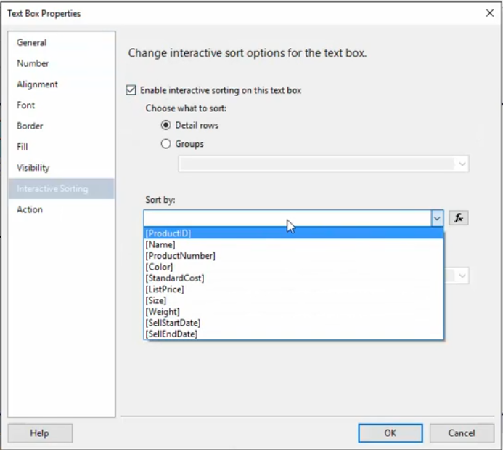

## INSERTING PAGE HEADER AND FOOTER

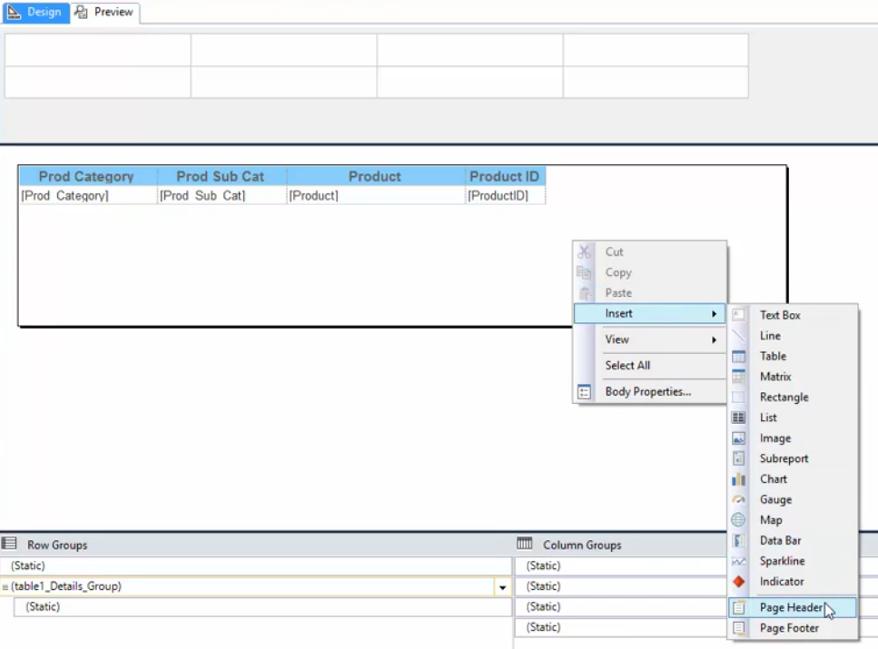

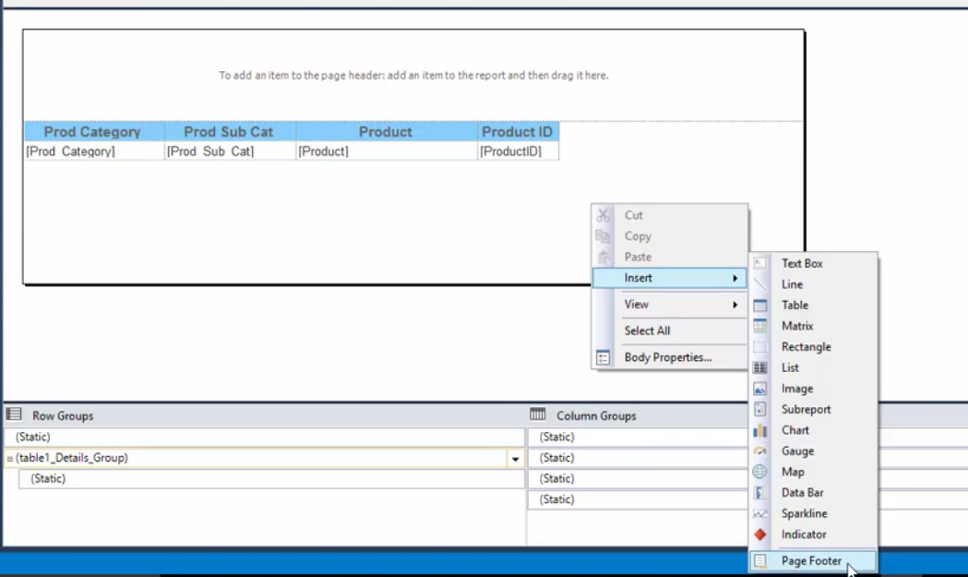

## ADDING TOTALS

Selecting the column field for which you want to calculate the sum, right click on the field and select Add Total from the menu.

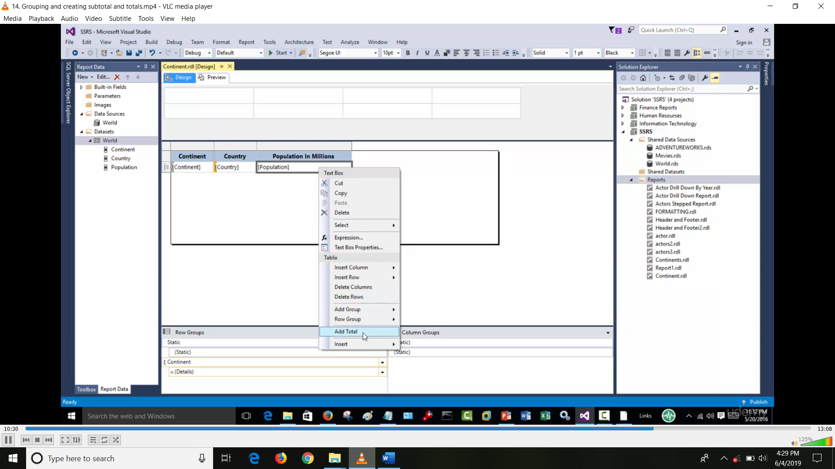

## TEMPLATE

To create a report template, create a report and copy that report from projects to ProjectItems/ReportProject:

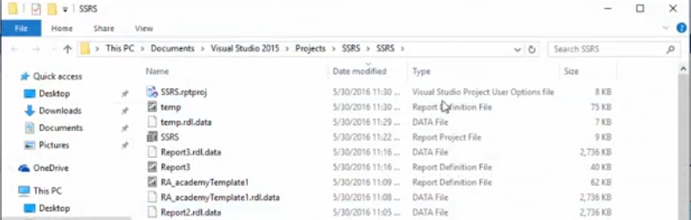

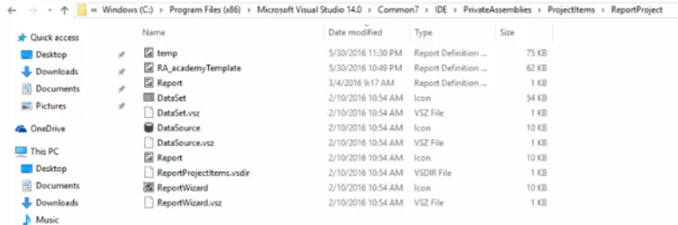

Next time you add a new item you will be displayed with below options in which we have the template which we created

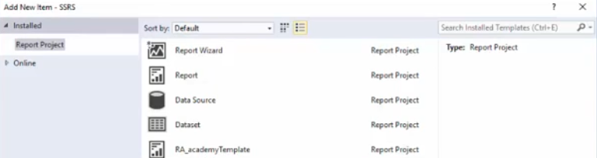

## DEPLOYMENT

While deploying the report to report server, two main setting to check are:

1. Target Report Folder (The report will be deployed under this folder / sub directory).
2. Target Server URL (Report server / web service URL).

## 

